Geethanjali College of Engineering and Technology
(UGC Autonomous)
(Affiliated to J.N.T.U.H, Approved by AICTE, New Delhi) Cheeryal(V), Keesara(M), Medchal Dist. – 501301.

A Report On BID2BUILD IDEATHON

Organized By:
CSE – AI & ML Department

Faculty Coordinator:
M. Keerthi

Overall Student Coordinators:

Akshay Satrashala A Lakshmi Deepak

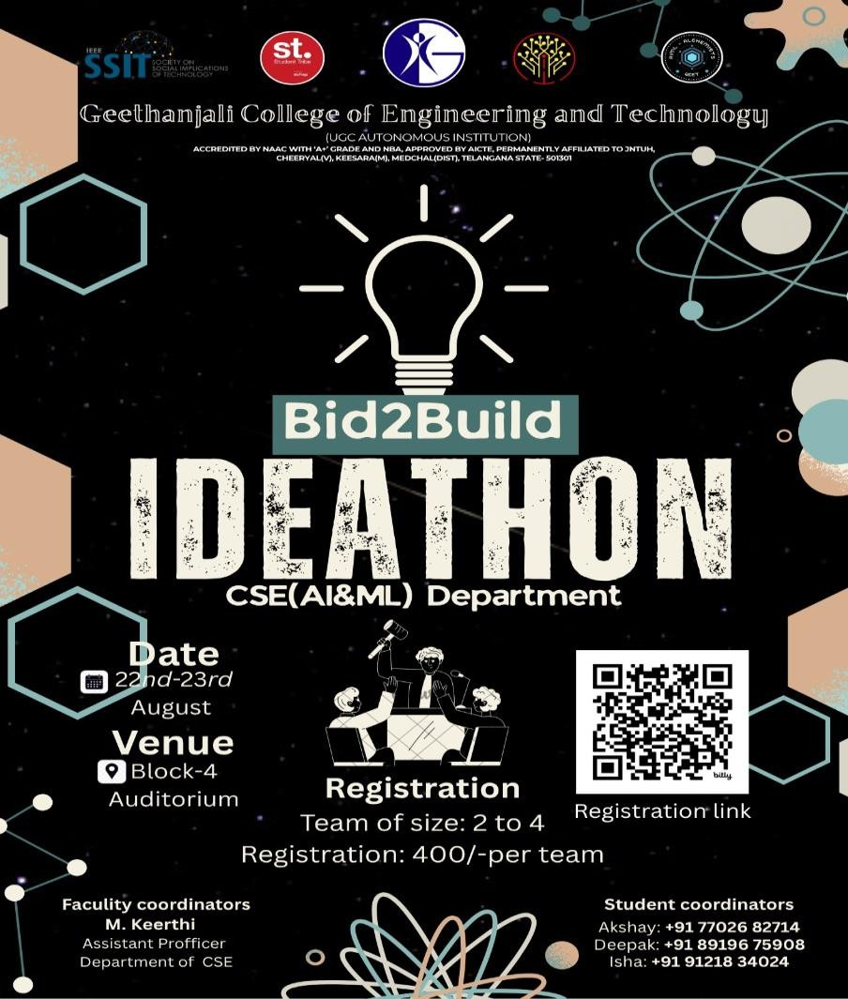
Poster:

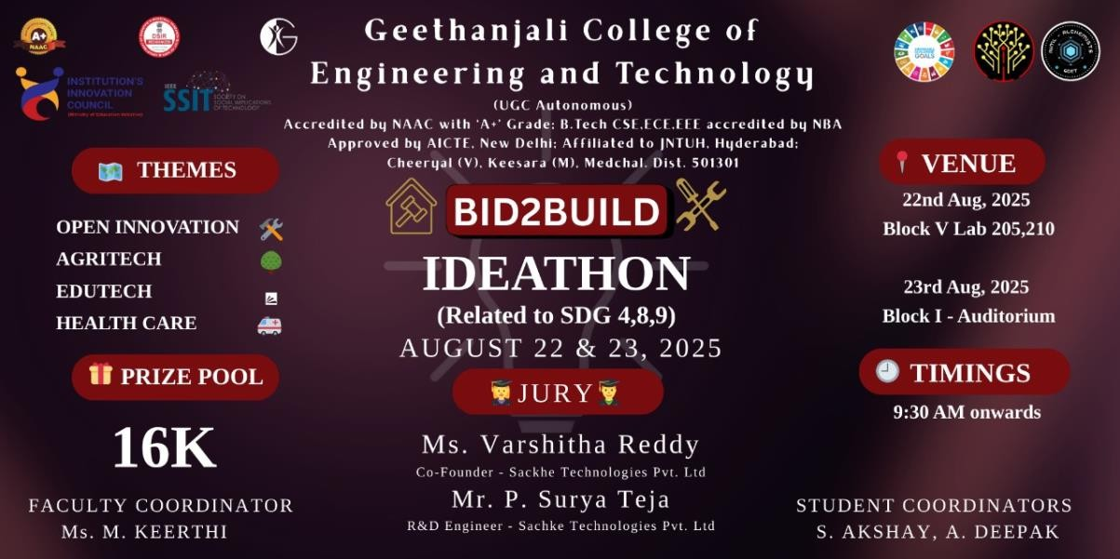
Banner:

Description:

BID2BUILD stood out as a flagship technical event hosted on 22nd and 23rdAugust, bringing together some of the brightest and most innovative minds from across the country for a Ideathon. The event was meticulously organized by the Department of CSE (AI & ML) at Geethanjali College of Engineering and Technology, under the guidance of esteemed faculty and with the enthusiastic support of student coordinators.
The Ideathon received an overwhelming response,154 with participants forming 45 competitive teams, out of which 12 Teams hailed from various prestigious institutions outside the host college, where 5 participants are from outside Telangana . Highlighting the national appeal and reputation of the event. This diverse participation created a vibrant and collaborative atmosphere, filled with enthusiasm, learning, and innovation.
Participants were invited to ideate and build solutions aligned with several cutting-edge and socially impactful themes, including:
- Open Innovation
- Agritech
- Edutech
- Health Care

Each team, consisting of 2 to 4 members, had the opportunity to develop real-time solutions to complex problems, showcase their technical skills, and pitch their ideas to a panel of expert judges. The event featured an engaging mix of brainstorming, late-night debugging, mentorship sessions, and high-energy collaboration
To honor excellence and innovation, BID2BUILD offered a prize pool of over
₹16000, with the top 3 winning teams receiving:
- 1st Prize – ₹
- 2nd Prize – ₹12,500
- 3rd Prize – ₹10,000
.
The event was organized with the support of:
- Chief Patrons: Sri. G. R. Ravinder Reddy (Chairman), Sri. R. Harish Chandra Reddy (Vice-Chairman)
- Patrons: Dr. S. Udaya Kumar (Director), Dr. K. Sagar (Principal)
- Conveners: Dr. V. Madhusudan Rao, Dr. A.Nageswara Roa

Ideathon Structure:

Day 1 – Ideathon Begins(August 22nd ,2025)
Every Participant:
- Start with Points in Your Account
  - Each participant is credited with a fixed number of points at the beginning.
  - These points act as your virtual currency throughout the event.
- Bid in a Live Auction
  - Use your points to participate in a live auction.
  - Place your bids strategically to secure the problem statement you like the most.
- Grab Your Favorite Problem Statement
  - The highest bidder wins and locks the problem statement.
  - Once locked, no other participant can claim it.

Day 2 – Jury Evaluation & Prize Distribution:
Each team presented their prototypes and pitched their solutions to a panel of distinguished jury members.
·ç "Y Jury Members:
VARSITHA REDDY:
Co-Founder – Sackhe Technologies Pvt. Ltd. | Oracle Functional Consultant – Winfo Solutions

VARSITHA REDDY is the Co-Founder of Sackhe Technologies Pvt. Ltd., leading the development of eco-friendly sanitary and solid waste management solutions, with two published patents on advanced incineration systems. Recognized by TGIC for Social Innovation, I am committed to creating impactful, sustainable solutions and have also published a chapter in the book Environmental Degradation & Solution by Sanskruthi Publications.
She have mentored students through programs like the YUVA initiative by Kakatiya Sandbox, led rural awareness sessions, and guided teams in IoT, design thinking and Prototyping. I also served as Vice Chair of the IEEE Student Branch at KGRCET, and contributed as a mentor and jury member at multiple hackathons, earning recognition for advancing technical education and community development.
Alongside my entrepreneurial journey, I work as an Oracle Functional Consultant at Winfo Solutions. My focus is on bridging academic learning with industry applications to inspire students to turn ideas into impactful solutions

Potlapally Surya Teja:
R&D Engineer – Sackhe Technologies Pvt. Ltd
.
Potlapally Surya Teja an Electronics & Communication Engineer with a strong foundation in Embedded Systems, IoT, Cloud Integration, and Blockchain applications. Currently working in the Research & Development department at Sackhe Technologies Pvt. Ltd., Developed working prototypes for 10 startups, including collaborations with Bifocal, Ayurva, and Bintix etc.. In addition to startup projects, also designed and implemented numerous innovative engineering projects for students across various domains and

conducted 10+ technical training sessions, mentoring over 1000 students from various colleges in AP and TG including GenAI Hackathon powered by Nasscom, Futureskills Prime and Smartbridge, and actively contributed as a jury member in prestigious hackathons, including TECHHACK#3 at Anurag University and large pitch and evaluate event at SRM University, AP. Passionate about bridging the gap between academic learning and real-world applications, I strive to inspire and guide students in turning their innovative ideas into impactful working solutions

